**INTRODUCTION**

"Catch The Deadline" is 2D game and designed for the PC, which is based on the movement and actions' of player. This game is totally aims to entertain users with broad gameplay and options. Variaty in the game, is making "Catch The Deadline" different from the other games. To pass the levels, user should take the power-ups which will help to kill enemies and passing the obstacles. Apart from the ordinary 2D games, "Catch The Deadline" will be played at online database with multiple players. In addition to that, the game will provide users to interact with other players as well. The main purpose is the game is try to get high scores as much as they can, therefore it makes our game competitive. For the scores, our constrain is time ellapsed to end the level. The players will face up with two diffrent game option, one of them is play as guest and the other one is sign up. If the user creates an account for the "Catch The Deadline" their scores will be saved and they can compete with other users. However, if a player choose to play as a guest their scores will not be saved.

While developing the game, as it mantioned above we have tried to create entertaining game for the users. To do so, our interface should be clear, colorful and understandable. Moreover, in the gameplay screen, user should not be bored and confused while trying to pass the levels. Whenever user passes a level they will face up with more difficult level in terms of enemies and obstacles.

All in all, "Catch the Deadline" is for the all the gamers that they love to play arcade games. With diffrent power-ups and weapons, players can create their own strategies to get high scores and pass the levels. User friendly interface and clear explanations about the game will help all type of the users to get used to gameplay.

**Main Menu**

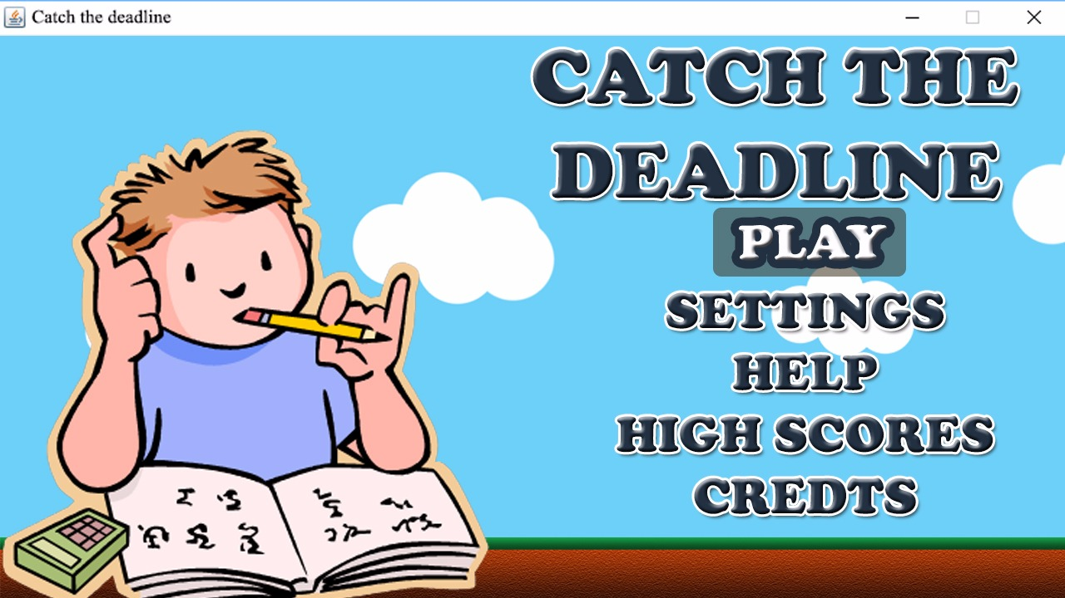

In the gameplay screen, user will see a simple, colorful menu to make their decisions about the "Catch The Deadline". Play button lets to user go through the game and start playing on it. Settings button provides user to make their own configurations about the game. In high scores, as the name suggests, user can see the all high scores that is consist of the other players scores'. In credits part, user will be see the designers of the game and information about the game.

**Pause Game Menu**

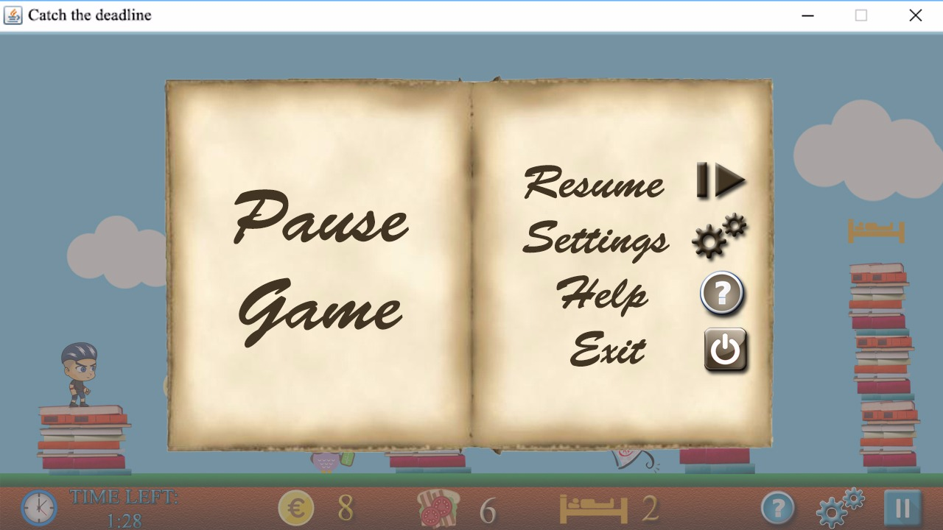

During the playtime, user is able to stop the game for diffrent reasons. If user wants just a break he can pause the game and they can continue from where they are left. Also user can go the settings menu to change configurations. Moreover, user can go through the help menu to check the buttons of the game. By just pressing exit button, user can leave the recent game.

**Settings Menu**

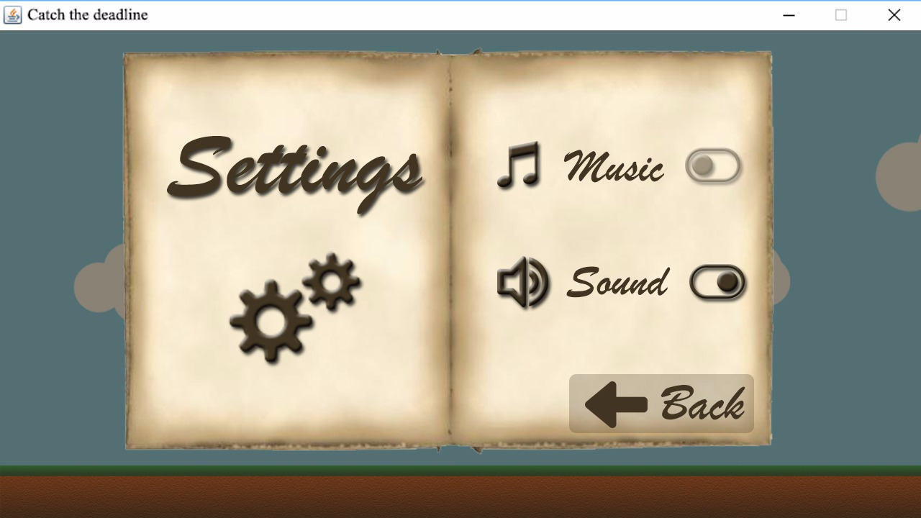

In the settings menu, user can turn off or on both music and the voice effects of the game.